Lab Exercise - 20
Name: Vyansh Sinha
SAP ID:500120123
Roll no: R2142231844
Batch: Devops B1
Index.html
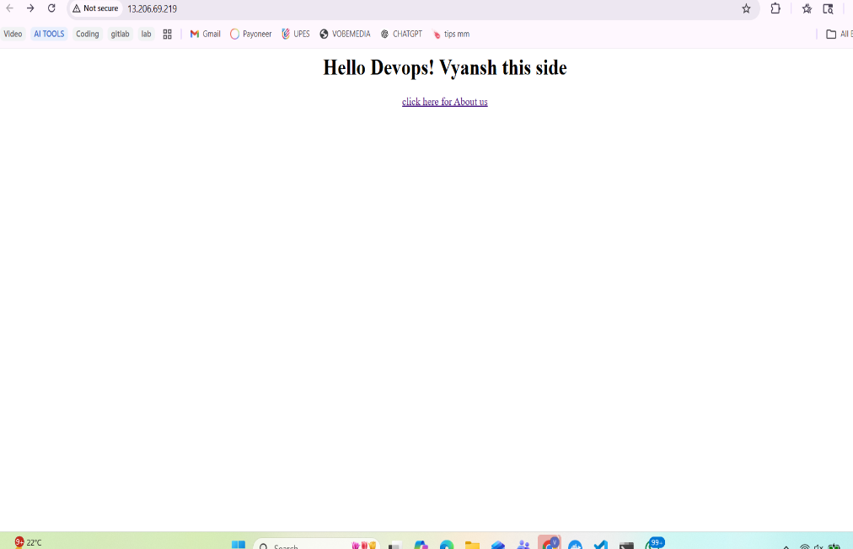

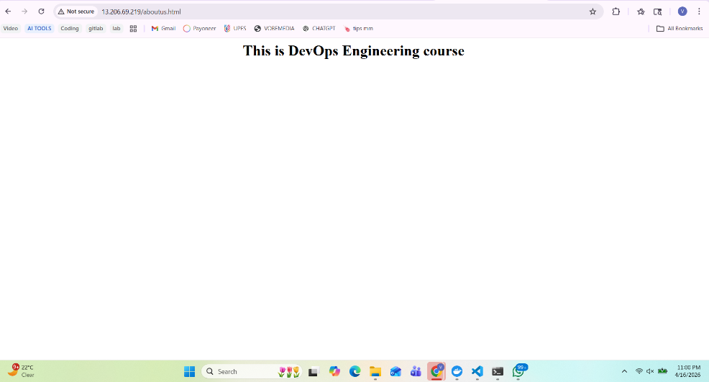
aboutus.html

